ST. PAUL’S PRESCHOOL REGISTRATION SCHOOL YEAR 2022 – 2023
It is hard to believe that the time has come for you to enroll your child for the fall of 2022 program. Please read over the following steps. If you have any questions call the school office for clarification.
It is important to remember that all registration forms will be prioritized and sorted based on your longevity at our school. You will then be assigned a session (AM or PM) according to your family registration number that was assigned to you when your oldest child started school at St. Paul’s. Once again be reminded that our cut-off date to enroll in the age appropriate class is December 31st of 2022.

GENERAL INSTRUCTIONS ↓
Registration cards will be available on a table outside the office beginning February 8th.

- Pick up a Registration card as well as an Emergency card; take it home and fill it out. Choose your preferred class and session time (morning / afternoon). ↓
- Go to www.stpaulspreschooltustin.org and click on the PARENT TAB at the top of the page. Then click again on the word FORMS.
    - Currently enrolled students should open the ‘RETURNING STUDENT’ file that has
5 attached forms.
    - For siblings or students new to St. Paul’s open and download the ‘NEW STUDENT’
forms that has 11 attachments.
    - Fill out the forms completely and legibly.
- Return ALL paperwork to the school office along with your payment (2022 fees are listed at the end of this flyer) on the correct registration scheduled date listed below. Failure to make the deadline will jeopardize your session (a.m. or p.m.) placement.
  - Please note we WILL NOT accept partially filled out paperwork. We are making this change because we have had difficulty collecting missing forms. This requires many additional hours on our office administrator to follow up with and track down those families with outstanding registration materials required by the State of California Dept. of Social Services Licensing Division. ↓
- Once again remember that registration will be processed according to your family registration number. Before Easter break we will post the morning and afternoon participants.
- If your first choice was the morning session but you were placed in the afternoon program due to space constraints, we will automatically create a morning wait list for your child. As openings occur we will contact you.

REGISTRATION SCHEDULE –
Please register between the office hours of 9:00 – 2:45

- ST. PAUL’S CHURCH MEMBERS and PRESCHOOL BOARD MEMBERS:
Wednesday or Thursday, February 9th or 10th

- CURRENTLY ENROLLED TU-TH; MWF and 5 Day STUDENTS:
The week of February 14th through 17th

- SIBLINGS and RETURNING FAMILIES:
Tuesday February 22nd through 25th
(Continued on other side)

- CURRENTLY ENROLLED PARENT and ME
During your regular class time either Tuesday February 22nd or Thursday February 24th
(Please note that your forms will be processed directly after siblings and returning families).

- WAIT LIST FAMILIES
We will begin calling our families on our wait list beginning March 1st
This process will take a few weeks so be patient!

TUITION FEES
Annual registration fees of $127.00 are required for every program offered at St. Paul’s except for the Parent & Me class which incurs a $52.00 fee.
At the time of registration both the registration fee and one tuition payment are due. While the registration fee is non-refundable the tuition deposit is refundable if the child is withdrawn before JUNE 1ST of 2022. We will not be able to refund your tuition money after this date.

PLEASE WRITE ONE CHECK INCLUDING THE REGISTRATION FEE. CHECKS SHOULD BE MADE OUT TO ST. PAUL’S PRESCHOOL. ZELLE OR BRIGHTWHEEL PAYMENTS ARE ALSO ACCEPTED.

Tuition payments for the 2022 – 2023 school year are:

TK and 5 Day $615.00 + $ 127.00 = $742.00
M/W/F $430.00 + $ 127.00 = $557.00
T/T $300.00 + $ 127.00 = $427.00
Parent & Me $130.00 + $ 52.00 = $182.00

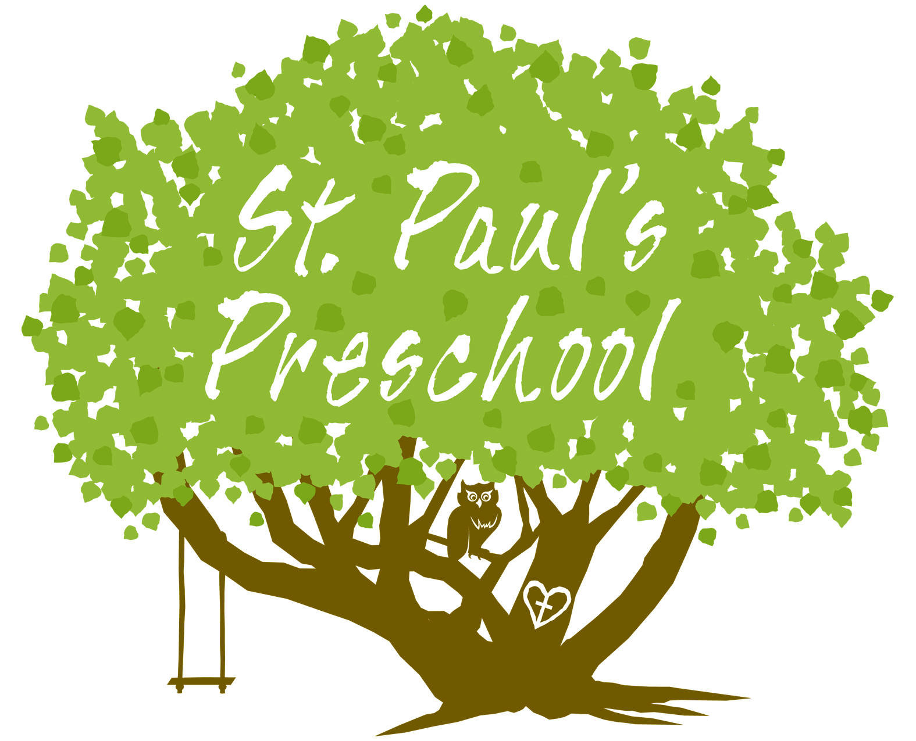

Thank you for choosing St. Paul’s Preschool for your child’s early learning years!

